**PRACTICAL-7**

**SUBJECT:** **Embedded Programming**

**SUBJECT_CODE:** **CAT-851**

**UIC DEPARTMENT**

**7.Write a program to use IR sensor to get output two leds on raspberry pi.**

**Ans:**

**#IR Sensor Module:**

IR sensor are modules which detect the pressure of objects before them if the ouput is present it gives 3.3V as output and if it is not present gives 0V.

**#Material Required:**

1. Raspberry Pi3 b+
2. IR sensor module
3. Red led light
4. Bread Board
5. Jump wires

**#Steps of Execution and Connection:**

1. Build the circuit
2. Write the python code
3. Execute the code
4. Then Led light will going high when there is no object in front of sensor.

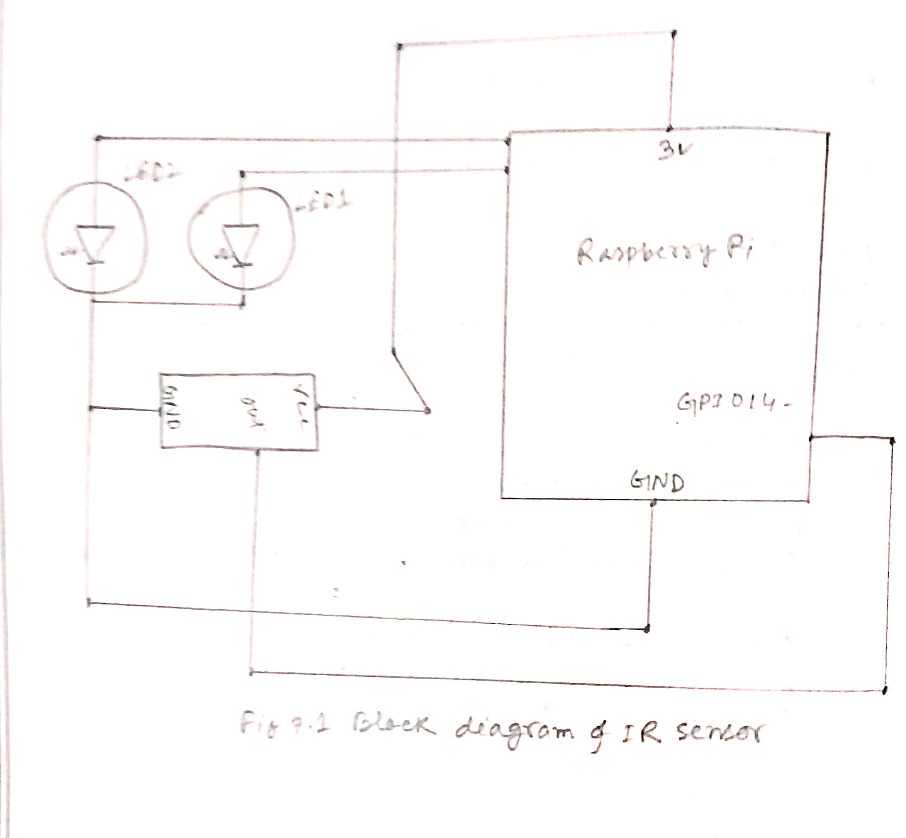

**#Code:**

Import PRi.GPIO as IO

Import time

IO.setwarnings(False)

IO.setmode(IO.BCM)

IO.setmode(2,IO.OUT)

IO.setmode(3,IO.OUT)

IO.setmode(14,IO.IN)

While 1:

If (IO.input(14)==True):

IO.output(2,True)

IO.output(3,False)

If (IO.input(14)==False):

IO.output(3,True)

IO.output(2,False)